How to create pipeline in data factory

1. Go to resource group vp
2. Go to data factory vp4
3. Launch studio
4. Go to authors

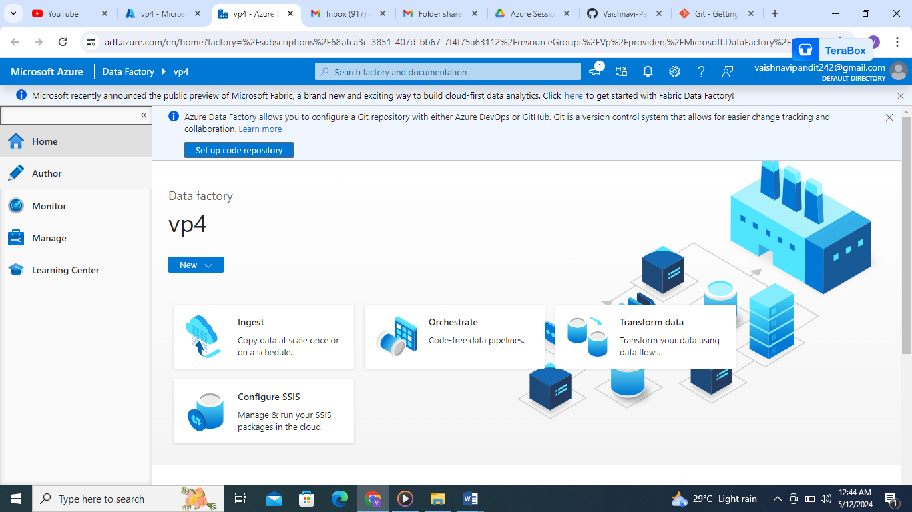

1. Go to pipelines
2. Create new pipeline

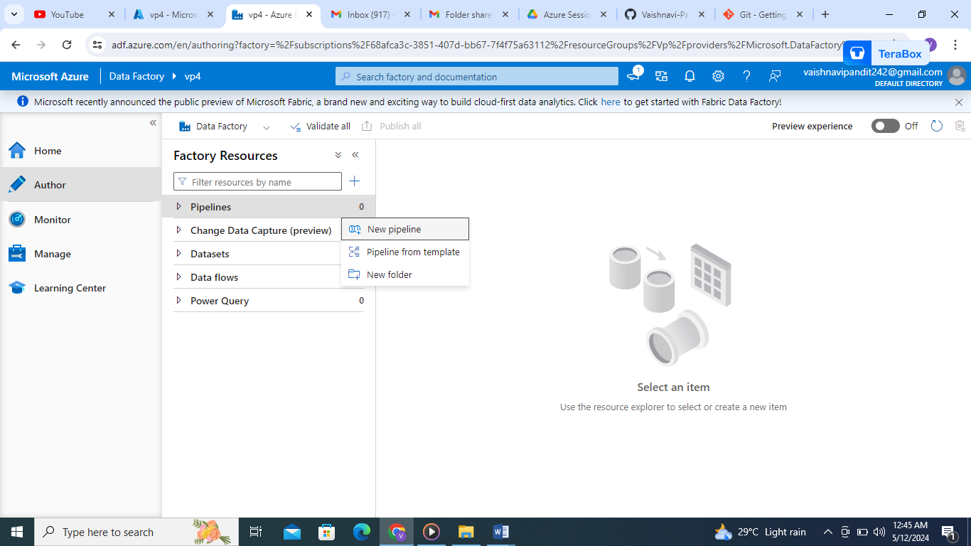

1. Enter pipeline name on right side

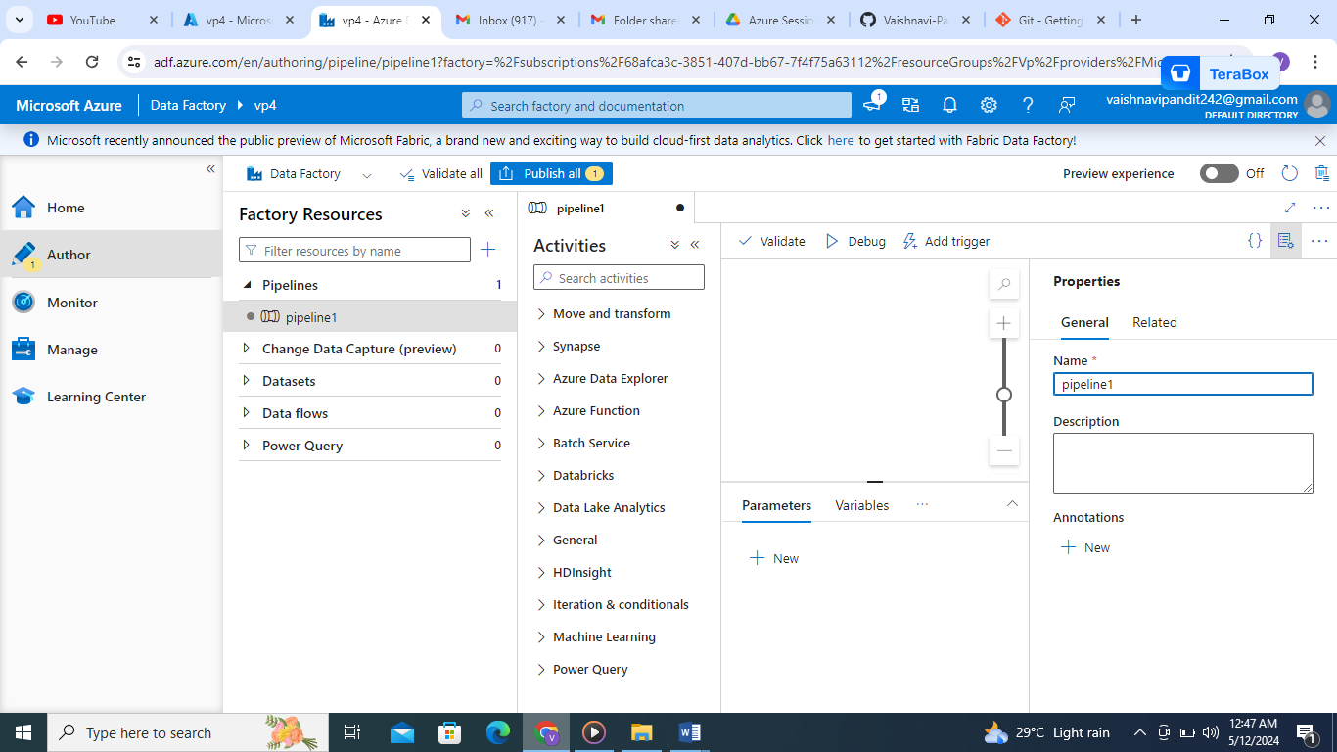

1. Go to variables below

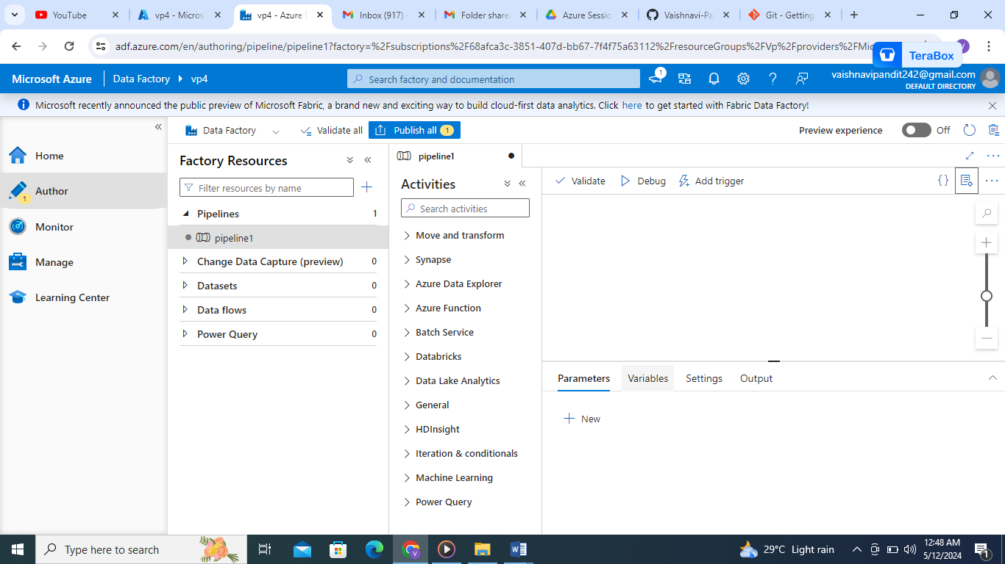

1. Go to new and add variable



1. Add name getname and go to settings add value

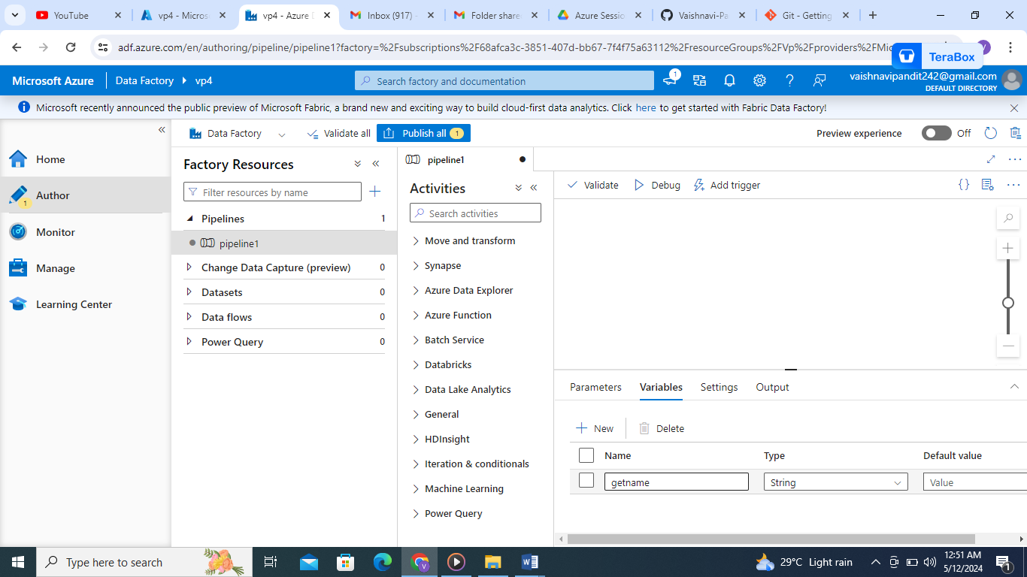

1. Now got to general drag and drop set activity

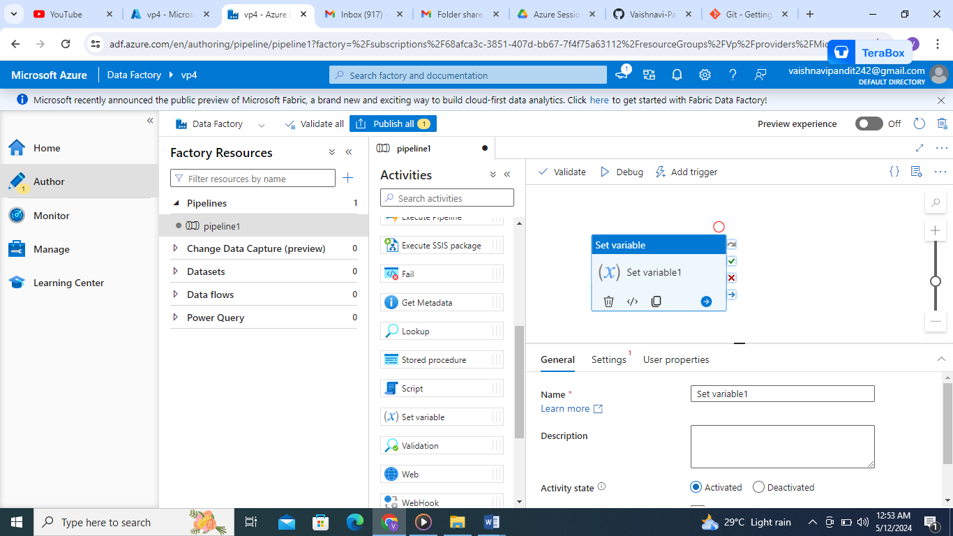

1. Click on set variable add name get name and go to settings and add variable getname

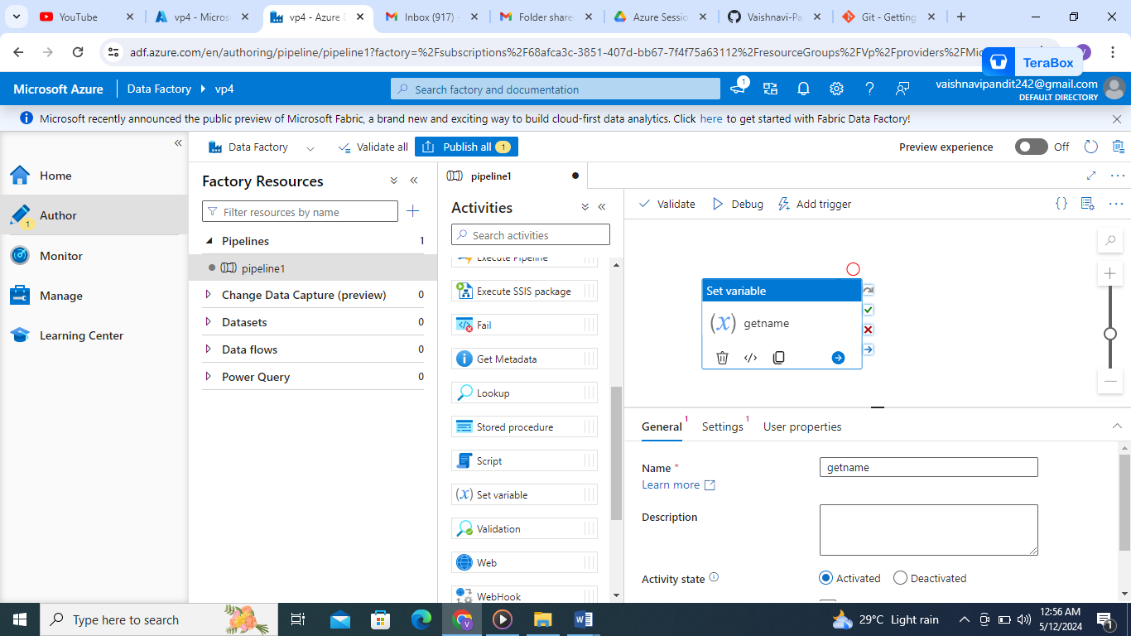

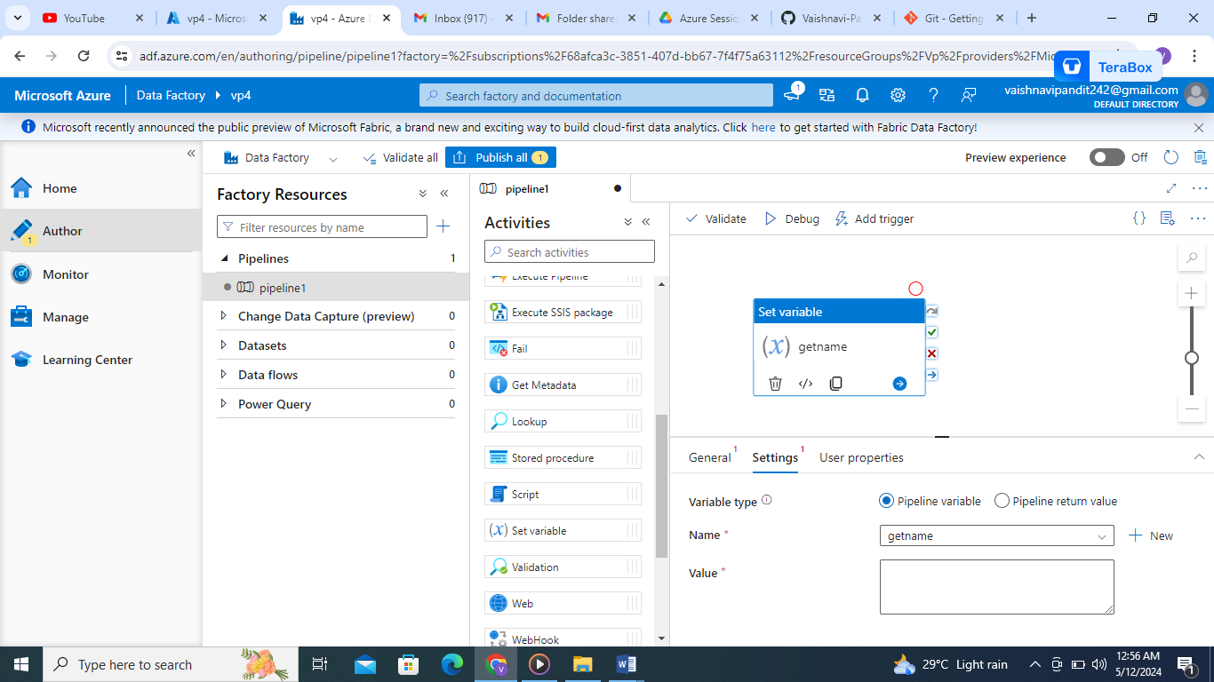

1. Now add value and debug
2. And see the output by clicking the arrow near variable name
3. Output=

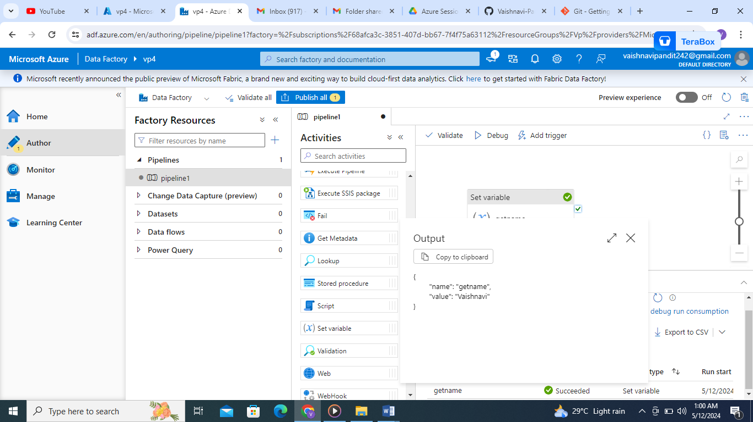

1. Similarly create another variable address and create get address activity and add value

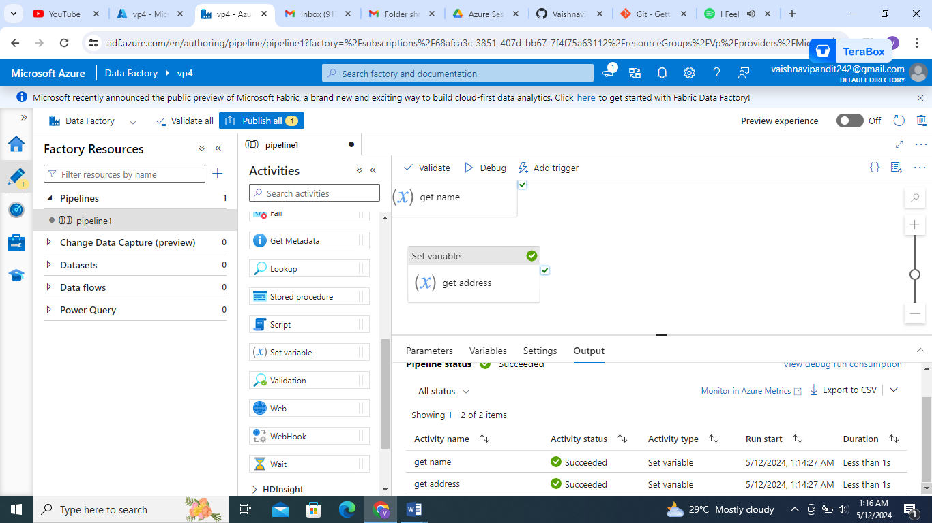

1. Now create one more variable print add set activity with name message go to settings and add value using add dynamic content

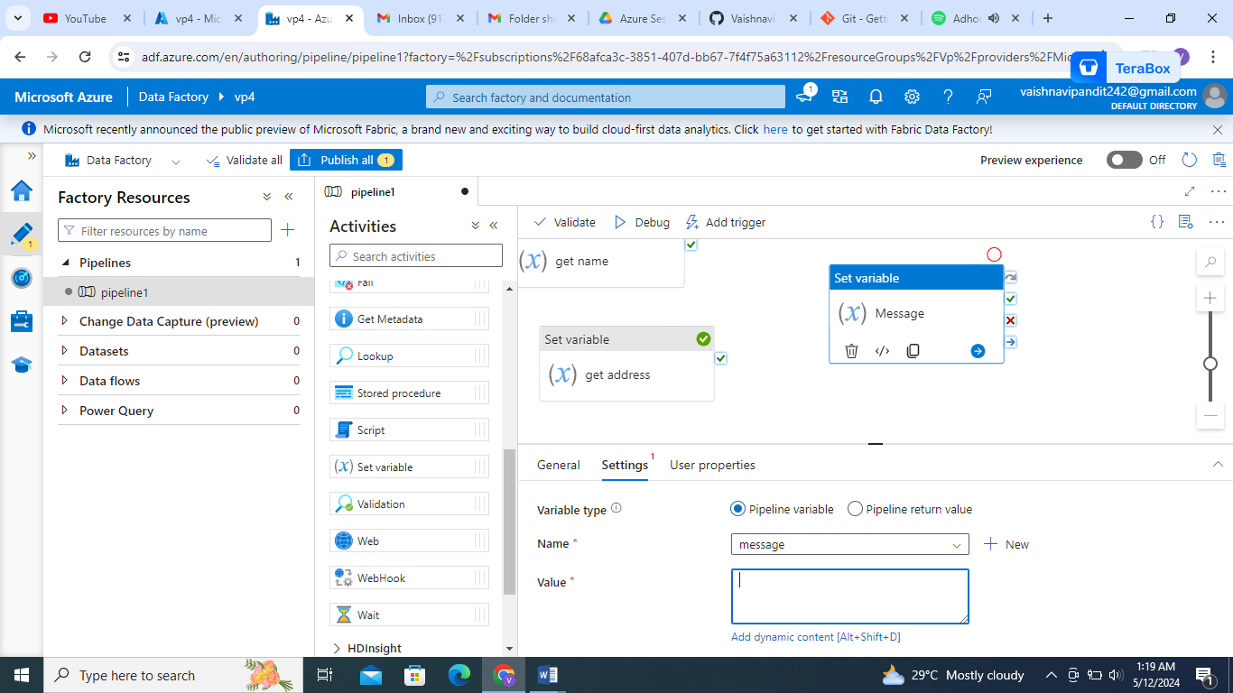

1. Now go to function string functions

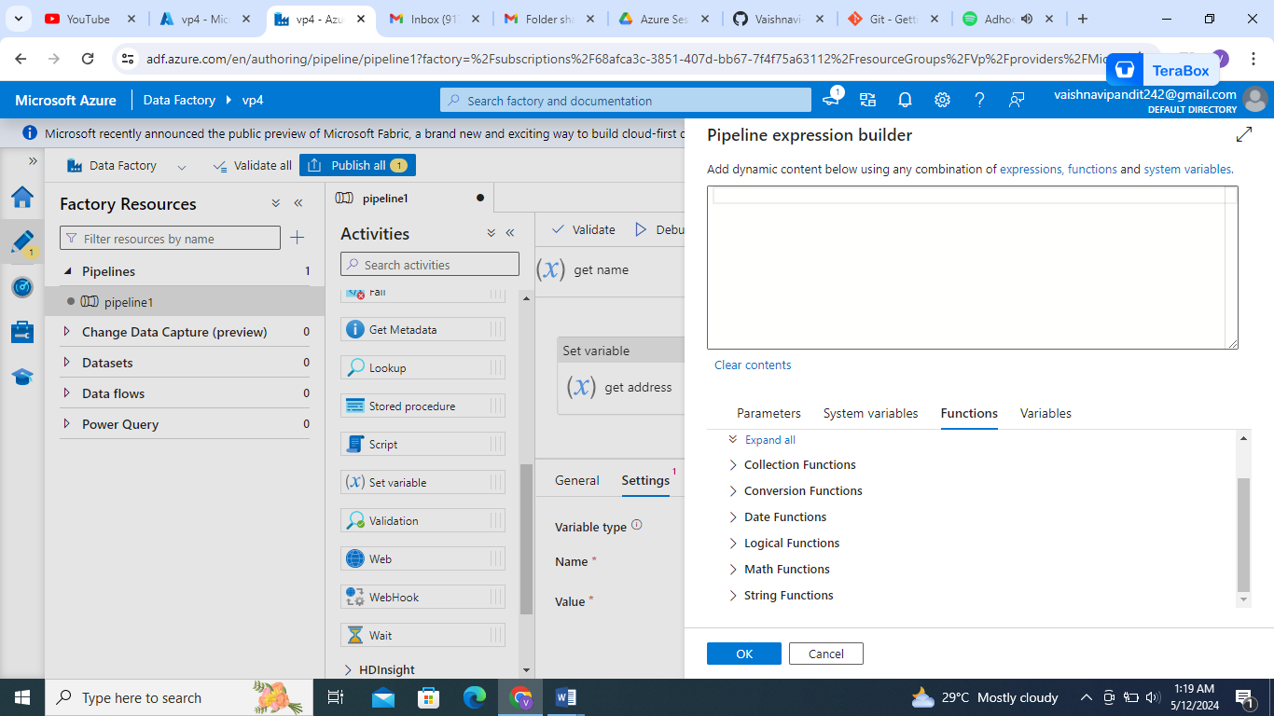

1. Now go to concat function and click

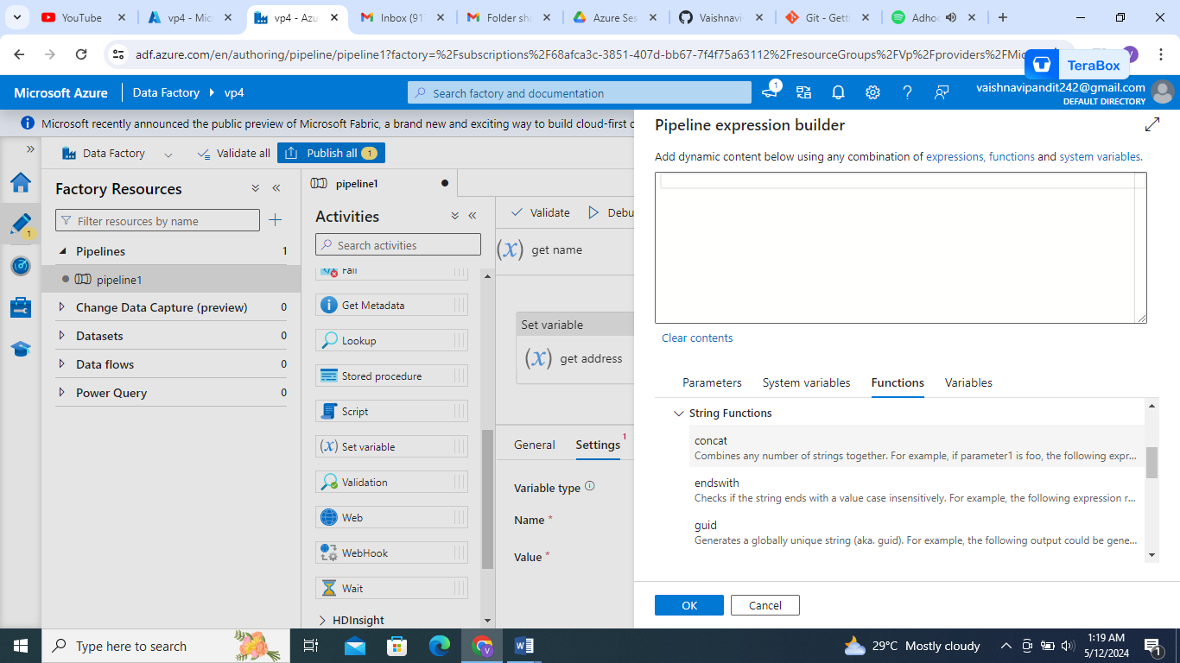

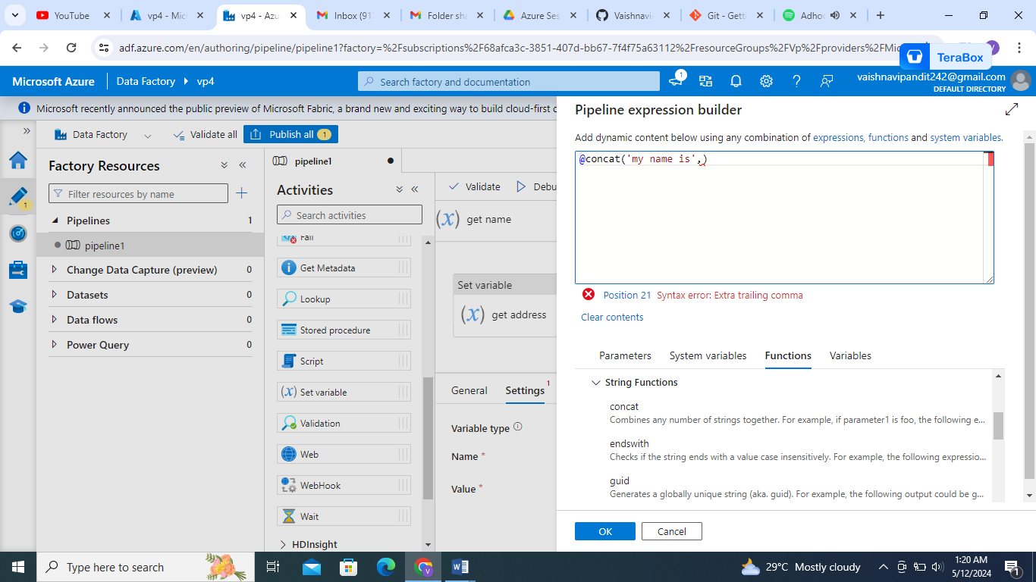

1. Now add variable go to variable and add name similarly do for address

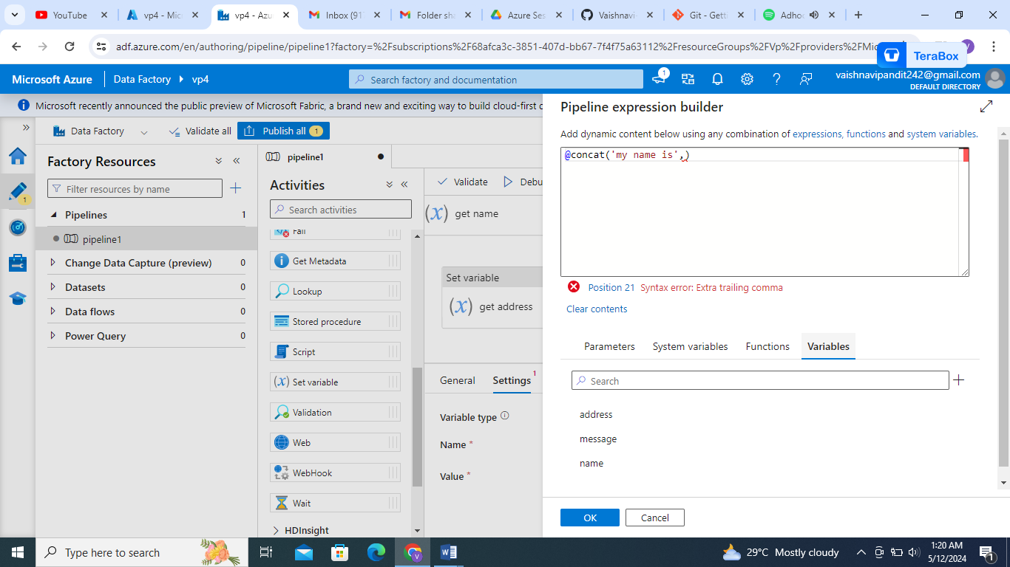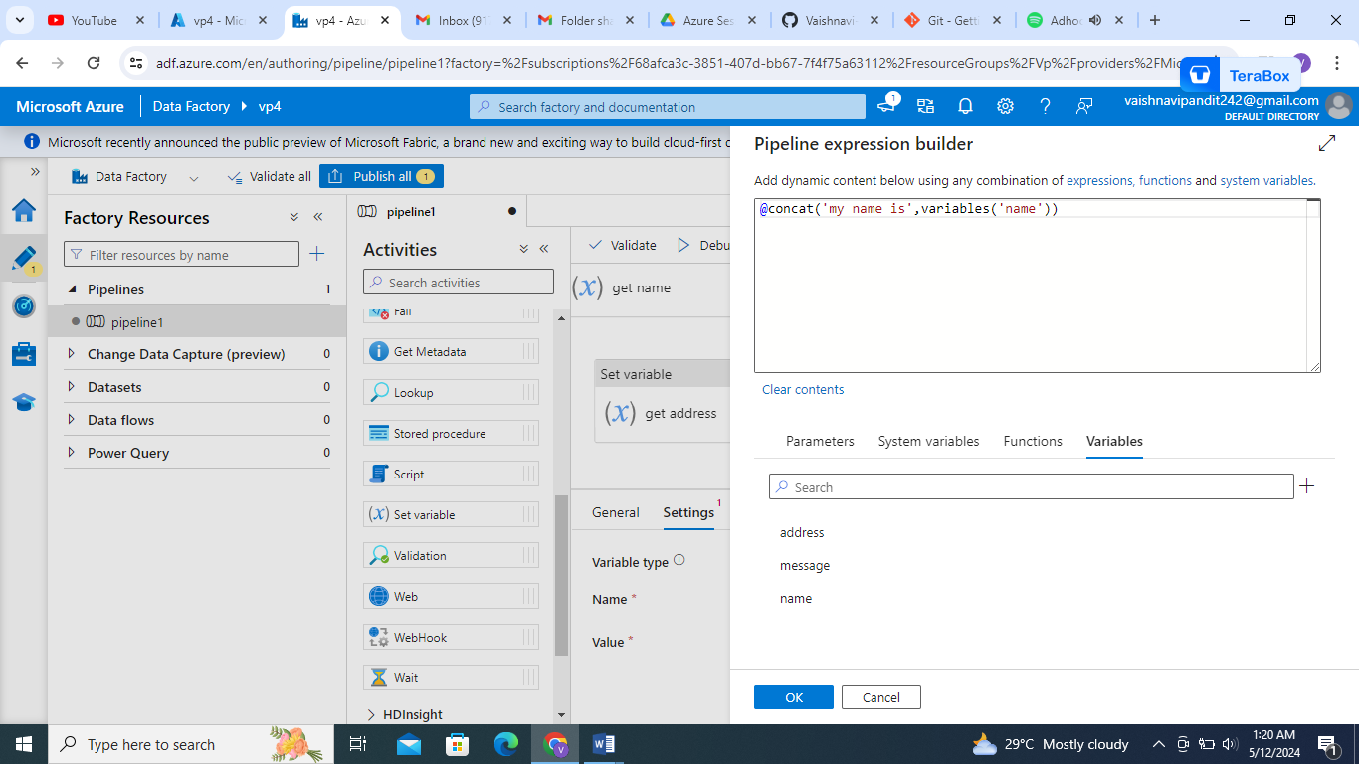

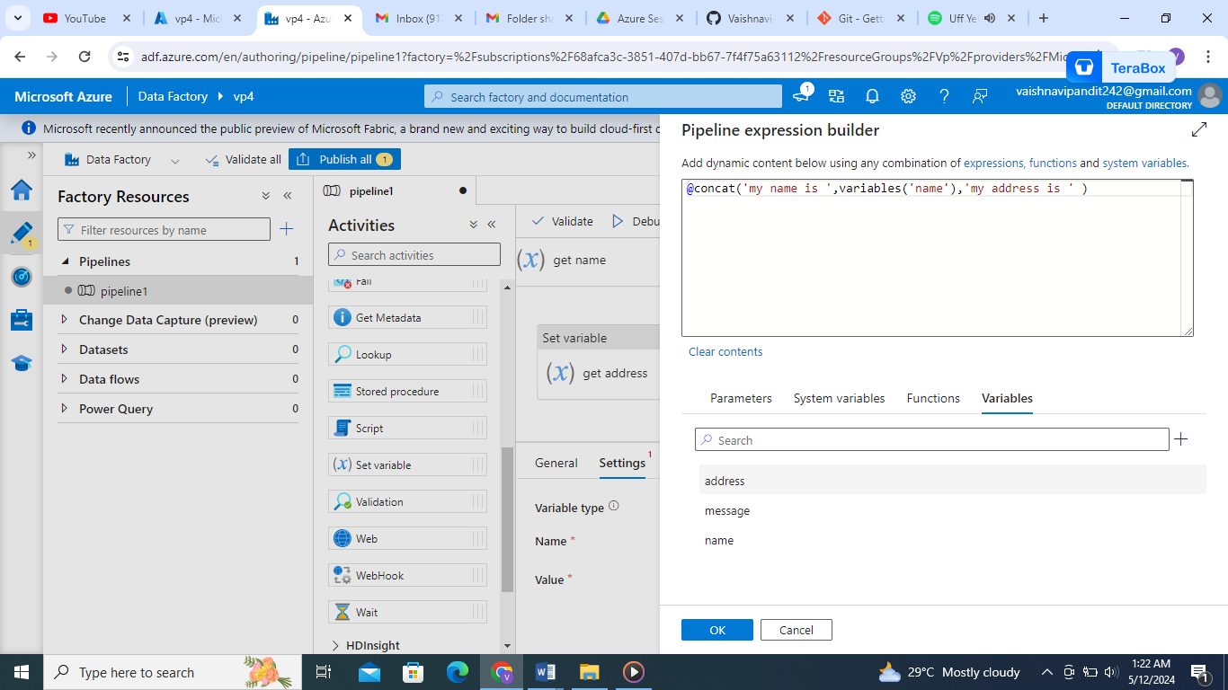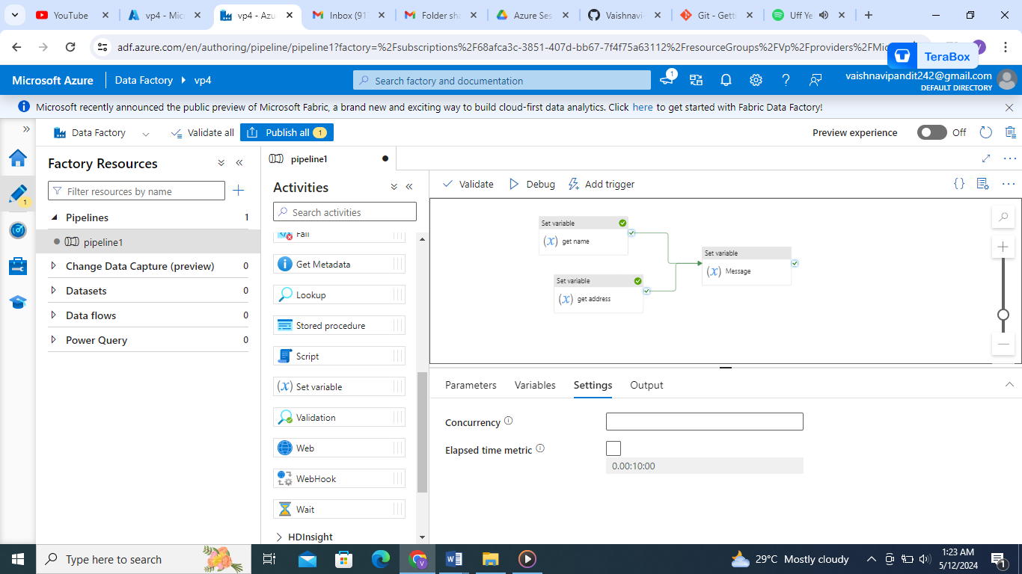

1. Now connect the name and address activities to message.

